 | ISO/IEC JTC 1/SC 2/WG 2 N3955
DATE: 2010-11-01

ISO/IEC JTC 1/SC 2/WG 2
Universal Multiple-Octet Coded Character Set (UCS) - ISO/IEC 10646
Secretariat: ANSI

DOC TYPE: | Calling Notice Meeting 58
TITLE: | 1st Call Meeting # 58 hosted by the Finnish Standards Association (SFS), http://www.sfs.fi, in Helsinki, Finland from 2011-06-06/10.
SOURCE: | Mike Ksar, Convener
PROJECT: | JTC 1.02.18 – ISO/IEC 10646
STATUS:
ACTION ID: | ACT – Those who need a visa to Finland need to send a request to the host in Helsinki. Make plans to attend and provide input on agenda items. Logistics details are in document N3939. Contact persons at SFS:  Visa Processing: Visitors from a number of countries will be required to have a valid passport and a valid visa. The visas must be obtained before departure and the applications should be made to a Finnish Embassy or Consulate in your country of residence. For further information, see the internet site of Ministry of Foreign Affairs of Finland: http://formin.finland.fi/Public/default.aspx?contentid=69601&nodeid=15716&contentlan=2&culture=en-US  If you need a letter of invitation, please contact Ms. Hillevi Vuori or Ms. Sari Lamminaho at SFS (details above).
  Ms. Hillevi Vuori | Ms. Sari Lamminaho
  e-mail: hillevi.vuori@sfs.fi  tel. +358 40 356 8003  fax +358 9 146 4925 | e-mail: sari.lamminaho@sfs.fi  tel. +358 9 1499 3466  fax +358 9 146 4925
DUE DATE: | 2011-05-23
DISTRIBUTION: | SC2/WG2 members and Liaison organizations
MEDIUM: | Electronic
NO. OF PAGES: | 6

This is the first call for WG2 meeting # 58 from 6-10 June 2011 in Helsinki, Finland and an agenda outline. The WG2 meeting starts at 10:00 am Monday, 6 June 2011 and conclude by noon time Friday 0 June 2011. The SC2 plenary is planned for Friday afternoon 10 June 2011. The call and the agenda will be announced by SC2 Secretariat.

The objective of this meeting is to continue the WG2 program of work, with focus on the 3rd edition of ISO/IEC 10646 FCD and PDAM 1. Contributions, including ones that have been carried forward will be reviewed as well.

Mike Ksar
ISO/IEC/JTC 1/SC 2/WG 2 Convener  22680 Alcalde Rd  Cupertino, CA 95014 – U. S. A. | Phone: +1 408 255-1217  e-mail: mikeksar@10646.com  mikeksar@gmail.com
Agenda Outline – Meeting # 58
Topic (Document No.) | Proposed Outcome

- Opening and roll call Update WG2Distribution List
- Approval of the agenda Approved agenda
- Approval of minutes of meeting 57 Approved Minutes
- Review action items from previous meeting Updated Action Item List
- JTC1 and ITTF matters: FYI
- SC2 matters: FYI
  - SC2 Program of Work FYI
  - Submittals to ITTF FYI
  - Ballot results FYI
- WG2 matters:
- IRG status and reports
- Script contributions related to ballots:
- Script contributions not related to ballots
- Ballots disposition of comments
  - FCD - 3rd edition
  - PDAM1 - 3rd edition
- Architecture issues
- Publication issues
- Defect reports
- Liaison reports
  - Unicode Consortium
  - IETF
  - SC22
  - W3C
  - SEI
- Other business
  - Web Site Review
  - Future Meetings
    - Meeting 59 – 1st Quarter 2012, Mountain View, CA, USA (pending confirmation),
Germany (as backup)
    - Meeting 60 – 4th Quarter 2012, Germany (pending confirmation), Thailand (Backup)
    - Meeting 61 – 2nd Quarter 2013 – Looking for host
- Closing
  - Approval of Resolutions of Meeting 58
  - Adjournment

JTC1/SC2/WG2 N3939

Date: 2010-10-05

LOGISTIC Information

Here are the logistic details for the ISO/IEC JTC1/SC2/WG2 Meeting 58 and SC2 plenary meeting in Helsinki, Finland, 2011-06-06/10.

Dates June 6th–10th, 2011

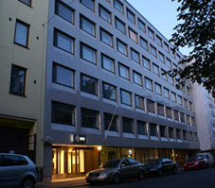
Host & Location

Finnish Standards Association (SFS)

http://www.sfs.fi

Malminkatu 34

FI-00100 Helsinki, Finland

Contact persons at SFS:

Ms. Hillevi Vuori

e-mail: hillevi.vuori@sfs.fi

tel. +358 40 356 8003

fax +358 9 146 4925

Ms. Sari Lamminaho

e-mail: sari.lamminaho@sfs.fi

tel. +358 9 1499 3466

fax +358 9 146 4925

The SFS premises are located in the Helsinki city centre. There is a wide range of hotels, restaurants and shops within walking distance.

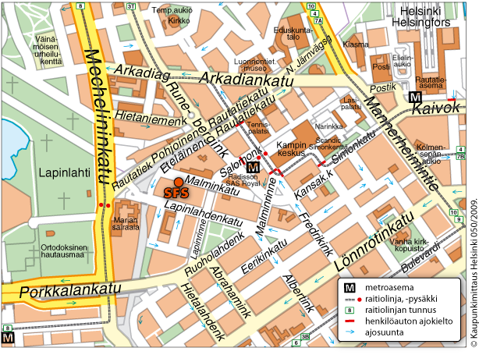

See also Google maps:http://maps.google.com/maps?q=Malminkatu+34,+00100+Helsinki,+Suomi&sll=37.0625,-95.677068&sspn=23.875,57.630033&ie=UTF8&hq=&hnear=Malminkatu+34,+00100+Helsinki,+Suomi&z=16

Registration

Please confirm your participation by May 18th by sending an e-mail to Ms. Toshiko Kimura (kimura@itscj.ipsj.or.jp) or a fax to +81 3 3431 6493. Please send a copy to the convener Mr. Mike Ksar (mikeksar@gmail.com) and SFS (it-info@sfs.fi or fax +358 9 146 4925).

Entry Visas

Visitors from a number of countries will be required to have a valid passport and a valid visa. The visas must be obtained before departure and the applications should be made to a Finnish Embassy or Consulate in your country of residence. For further information, see the internet site of Ministry of Foreign Affairs of Finland:

http://formin.finland.fi/Public/default.aspx?contentid=69601&nodeid=15716&contentlan=2&culture=en-US

If you need a letter of invitation, please contact Ms. Hillevi Vuori or Ms. Sari Lamminaho at SFS (details above).

Hotels

SFS has made a block reservation at the Radisson Blu Royal hotel. Please make your hotel reservation directly at the hotel.

In order to have your room with the contracted rate, please quote the client code when making the reservation.

Recommended hotel:

Radisson Blu Royal http://www.radissonblu.com/royalhotel-helsinki

Address: Runeberginkatu 2, 00100 Helsinki

- two minutes walk from SFS premises

Standard 154 € / night

The rates are valid June 5th–10th when reserved by May 18th, 2011. Client code SC2. Please note that the number of rooms at this rate is limited.

The rates include a Super Breakfast buffet during normal opening hours (VAT 23%), service, room charge VAT (9%) and sauna. High-speed and/or wireless Internet access is free of charge for all guests throughout the hotel.

Payment: Cash or credit card

Reservations: Central Sales Services

Telephone: +358 20 1234 700 / individual room reservations

Telefax: +358 20 1234 740

E-mail: reservations.finland@RadissonBlu.com

Please quote the client code SC2 when making a booking.

Other hotels with special rates within walking distance:

Hotel Scandic Simonkenttä http://www.scandichotels.com/en/Hotels/Countries/Finland/Helsinki/Hotels/Scandic-Simonkentta/?redirected=true

- ten minutes walk from SFS premises

Client code D000006032
Please check the best daily rates (Corporate Saver) at: www.scandichotels.fi

by using the booking code “D000006032” or phone +358 (0)800 0 6969/Scandic reservations centre.

Sokos Hotel Presidentti http://www.sokoshotelpresidentti.fi/en/index.html

- ten minutes walk from SFS premises

Client code SFS

The rates for the year 2011 will be completed later.

Hotel Helka http://www.helka.fi/

- five minutes walk from SFS premises

Client code SFS

The rates for the year 2011 will be completed later.

Getting to the city centre from the Helsinki-Vantaa airport

Buses and taxis are reliable and safe to use in Finland.

Bus services from the Helsinki-Vantaa airport take you to Helsinki city centre and back comfortably and rapidly. The trip to Helsinki city centre by bus 615 or Finnair City Bus takes approximately 35 minutes and costs around 6 €. Both the lines run to Helsinki Central Railway Station, situated within 15 minutes walk from the SFS premises.

The taxi journey from the airport to the centre of Helsinki takes about 30 minutes and costs about 35-40 €. The taxi stations are located right outside the arrival areas of the terminals. There are also three taxi operators at the Helsinki-Vantaa airport that offer special taxi services, fixed fare shared taxis and tours and chartered drives. See the service map for details: http://www.helsinki-vantaa.fi/servicemap

Electricity The electric current in Finland is 220 V (230 V), 50 Hz. A two-pin plug system familiar throughout Europe is used.

Weather The average daytime temperature in Helsinki in the beginning of June is around +15 °C, but the temperature may vary between +10 °C and +20 °C.

You can check the Helsinki five day weather forecast at Finnish Meteorological Institute’s site:

http://www.fmi.fi/weather/local.html?Keywords=&station=2934&param=4&map=1&place=Helsinki

Currency & Credit Cards

The Finnish currency is the Euro (€), with 100 cents (c) = 1,00 €.

Most major credit cards are accepted in hotels, restaurants and shops. However, some shops may not accept payment by credit card.

Tourism For tourist attractions and leisure activities in Helsinki, please visit the Helsinki official tourism site:

http://www.visithelsinki.fi/In_English/Visitor/Helsinki/Welcome_to_Helsinki!.iw3

See also the Visit Finland site:

http://www.visitfinland.com/en/web/guest/finland-guide/home

