 | ISO/IEC JTC 1/SC 2/WG 2 N4605
DATE: 2014-09-09

ISO/IEC JTC 1/SC 2/WG 2
Universal Multiple-Octet Coded Character Set (UCS) - ISO/IEC 10646
Secretariat: ANSI

DOC TYPE: | Calling Notice Meeting 63
TITLE: | 2nd Call Meeting # 63 hosted by Sri Lanka Standards Institution (SLSI) and the Information and Communication Technology Agency of Sri Lanka (ICTA) in Colombo, Sri Lanka from 29 September 2014 through 3 October 2014.
SOURCE: | Mike Ksar, Convener
PROJECT: | JTC 1.02.18 – ISO/IEC 10646
STATUS:
ACTION ID: | ACT – Those who need a visa to Sri Lanka need to contact Ms. Chamali Perera, Information and Communication Technology Agency for Sri Lanka (ICTA), chamalip@icta.lk. Make plans to attend and provide input on agenda items. Logistics details are in document N4576-A, attached below. It includes logistics info and recommended hotels near the meeting site.
DUE DATE: | 2014-09-22
DISTRIBUTION: | SC2/WG2 members and Liaison organizations
MEDIUM: | Electronic
NO. OF PAGES: | 5

This is the 2nd call for WG2 meeting # 63 from 29 September 2014 through 3 October 2014 hosted by Sri Lanka Standards Institution (SLSI) and the Information and Communication Technology Agency of Sri Lanka (ICTA) in Colombo, Sri Lanka. The WG2 meeting starts at 10:00 am Monday, 29 September 2014 and concludes by 9:30 am Friday 3 October 2014. The WG2 meeting on Friday will start at 8:00 am to review Results and Recommendations of the WG2 meeting. Note that SC2 plenary is scheduled as follows:
Day 1: 2014-09-30 (Tuesday) 10:00 – 12:00
Day 2: 2014-10-03 (Friday) 10:00 – 12:00

The objective of this meeting is to continue the WG2 program of work, with focus on 10646 4th edition as well as the results of Amendments 1 & 2 of the 4th edition of 10646. Contributions, including ones that have been carried forward will be reviewed as well.

The deadline for submitting documents is Monday 22 September 2014. It might be difficult for me to respond to your submittals but I will try to monitor your submittals. The agenda is under preparation and will be announced prior to the meeting.

Mike Ksar
ISO/IEC/JTC 1/SC 2/WG 2 Convener  22680 Alcalde Rd  Cupertino, CA 95014 – U. S. A. | Phone: +1 408 255-1217  e-mail: mikeksar@10646.com  mikeksar@gmail.com

ISO/IEC JTC1/SC2/WG2 N4576-A
Date: 2014-05-08

Logistics for JTC1/SC2/WG2 Meeting 63 in Colombo, Sri Lanka
29 September 2014 – 3 October 2014
Hosts | - Sri Lanka Standards Institution (SLSI)  17 Victoria Place, off Elvitigala Mawatha  Colombo 08, Sri Lanka  - Information and Communication Technology Agency of Sri Lanka (ICTA)  160/24, Kirimandala Mawatha, Colombo 05, Sri Lanka  www.icta.lk  +94 11 2369099, +94 11 2369100
Contact person | Ms. Chamali Perera  Information and Communication Technology Agency of Sri Lanka (ICTA)  chamalip@icta.lk  +94 11 2369099, +94 11 2369100 ext. 248.  Ms. Aruni Goonetilleke  aruni@icta.lk  +94 11 2369099, +94 11 2369100 ext. 298.
Meeting location | Crystal Room – Lower,  Hotel Taj Samudra  No.25, Galle Face Center Road, Colombo, Sri Lanka  Phone: + 94 11 2 446622  http://www.taj-samudra-colombo-colombo-sri-lanka.ww.lk/index.html
Hotel | Hotel Ramada Colombo  30 Sir Mohamed Macan Markar Mawatha  Colombo 03, Sri Lanka,  Phone: +94 11 2422001  Email: info@ramadacolombo.com  Web: http://www.ramadacolombo.com/  Single/double with no breakfast: USD 121 nett  Single with breakfast: USD 131 nett  Double with breakfast: USD 141 nett  Rooms: Please contact Charmaine when booking a room at the Ramada:  She’s the Banquet and Room Sales Coordinator.  Phone:  - Direct +94 11 4794307  - Mobile +94 773574801  - General +94 11 2422001  Email: charmaine@ramadacolombo.com  She requests you to email her, rather than book through the Internet, and say it is for the ICTA event (that is how Ramada has noted it).  Map  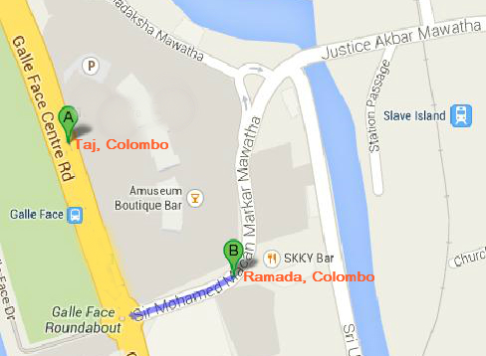
Entry visas | If you require a letter of invitation, please contact Chamali.  Visa:  The website address is: http://www.eta.gov.lk  Please use only the gov.lk site, not any other site.
Local weather  (forecast: for September/October) | 30º C
Currency | Approx 1 USD = 130 LKR (2014-05-05 – Central Bank of Sri Lanka)
Electricity | 220 – 240 V, 50/60 Hz.
Airport pickup | The host will provide airport pickup.

