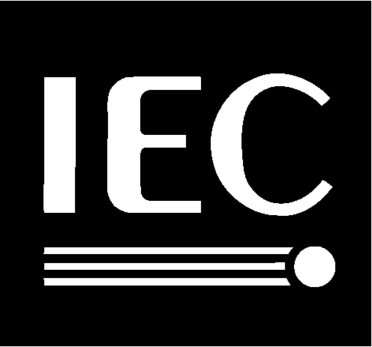

ISO/IEC
JTC 1 / SC 2 / WG 2
Recognizes
Michael Everson
For his dedication and enormous contribution as
Contributing Editor
to the publication of
ISO/IEC 10646-1: 2000,
Universal Multiple-Octet Coded Character Set (UCS) ―
Part 1: Architecture and Basic Multilingual Plane
22 September 2000

