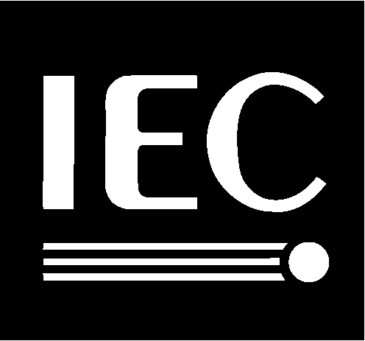

ISO/IEC
JTC 1 / SC 2 / WG 2
Recognizes
Michael Y. Ksar
For his exceptional leadership and vision as
Convenor
of JTC 1/SC 2/WG 2 for the past 10 years
For his dedication to ensure the successful development
of ISO/IEC 10646,
Universal Multiple-Octet Coded Character Set (UCS)
For his efforts to ensure full synchronization
of ISO/IEC 10646with the Unicode Standard
For his dedication, commitment
and professional contributions
for the advancement of internationalization.
22 September 2000

