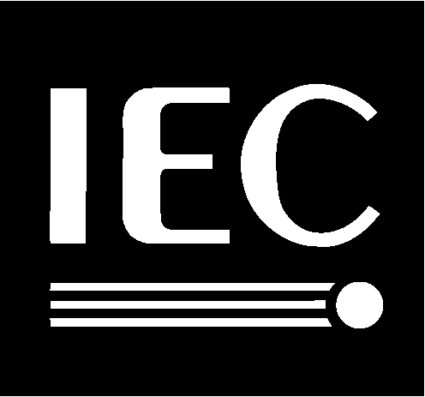

ISO/IEC
JTC 1 / SC 2 / WG 2
Recognizes
Bruce Paterson
For his dedication, painstaking effort and enormous contribution as Project Editor
of ISO/IEC 10646-1,
Universal Multiple-Octet Coded Character Set (UCS) ―
Part 1: Architecture and Basic Multilingual Plane
for the past 7 years
For his dedication to the successful development
of 3 corrigenda and 31 amendments to
ISO/IEC 10646-1: 1993
For his dedication for the successful publication of
ISO/IEC 10646-1: 2000
22 September 2000

