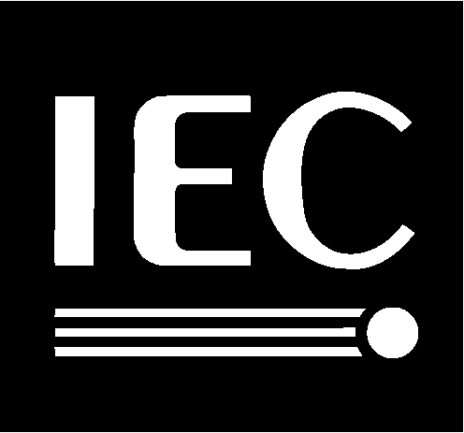

ISO/IEC
JTC 1 / SC 2 / WG 2
Recognizes
Dr. V. S. Umamaheswaran
For his dedication and sustained efforts as
Secretary
of ISO/IEC JTC 1/SC 2/WG 2
Universal Multiple-Octet Coded Character Set
for the last 8 years
22 September 2000

